Love 21 Foundation
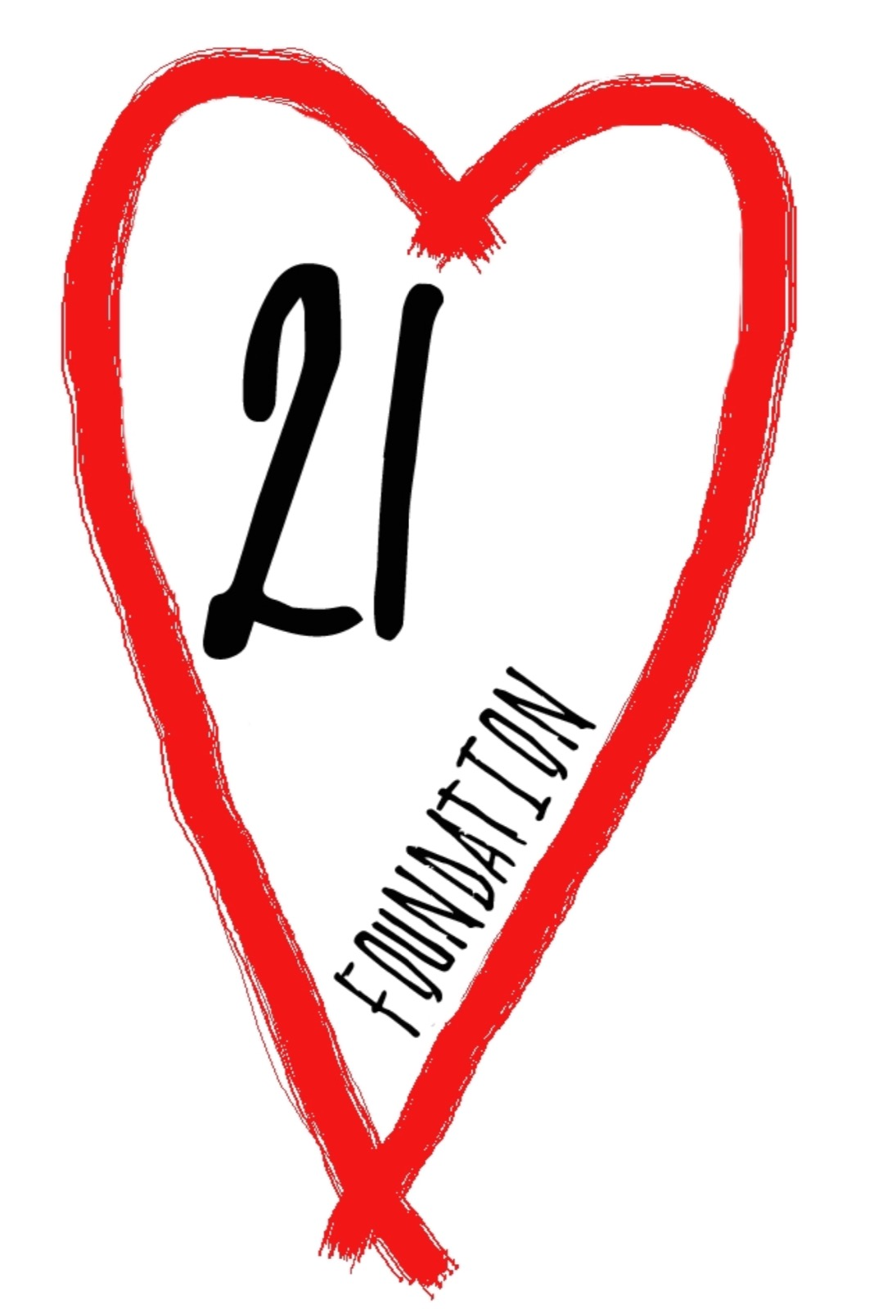
2018-2019

http://www.love21foundation.com/
Annual Report
nn

Table of Contents
Message from CEO 3
Mission 4
Objectives (2018-2019) 4
Program Summary – Sports 6
Program Summary – Nutrition 11
Special Events and Functions 12
Our Financials 13
We Need Your Help 16

CONTENTS

Message from CEO
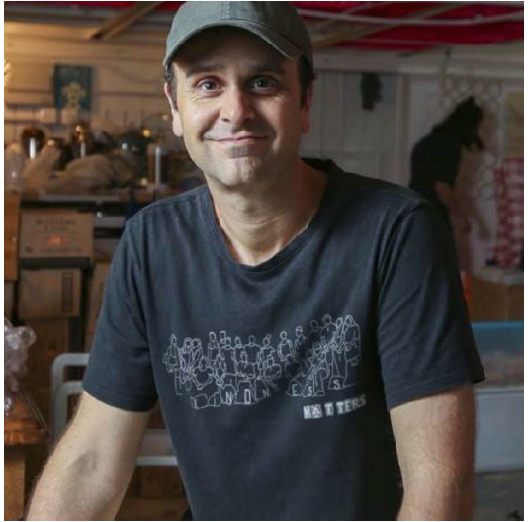
I would like to start by thanking all of you who have supported Love 21 Foundation and helped us over the past two years.
This experience has been a life changing one for me, to say the very least, and I’m extremely grateful to have had this opportunity!
During this period we expanded our range of healthy activities and were also able to invite more families to participate.
I would like to thank all of the families who have joined Love 21 Foundation. You all have been such great friends and have taught me so much! Your passion and positivity is inspirational and I cannot wait to continue progressing as individuals and as a community.
We want to continue empowering the parents as well as their children. It is our aim in the coming years to strengthen our holistic programmes to best support our beneficiaries.
We also hope to create more sports programmes which can include younger members.
We are very grateful to have employed a new Programme Manager, Kenneth Chan during this period. He has played a huge role in enabling us to take big steps forward in a very short time.
I’d also like to thank our Board of Directors for their unwavering support and dedication. Love 21 is extremely fortunate to have your expertise and care.
This next year is going to be a great one for Love 21 as we aim to have a home of our own, enabling us to invite more families to join and to further enhance the quality of our programmes.
Thanks again!
Jeff Rotmeyer

Mission

Love 21 Foundation empowers the Down syndrome and autistic community in Hong Kong by giving them an opportunity to reach their full potential through sport and nutritional programmes.

Objectives (2018-2019)

- To offer sport classes that caters to members of differentiating strengths and interests.
- To initiate and develop a nutritional programme to promote healthy eating to our families
- To provide holistic support to give our beneficiaries the greatest opportunity to find health, happiness and longevity
- To hire a full-time employee to handle the front-end and back-end operations of Love 21
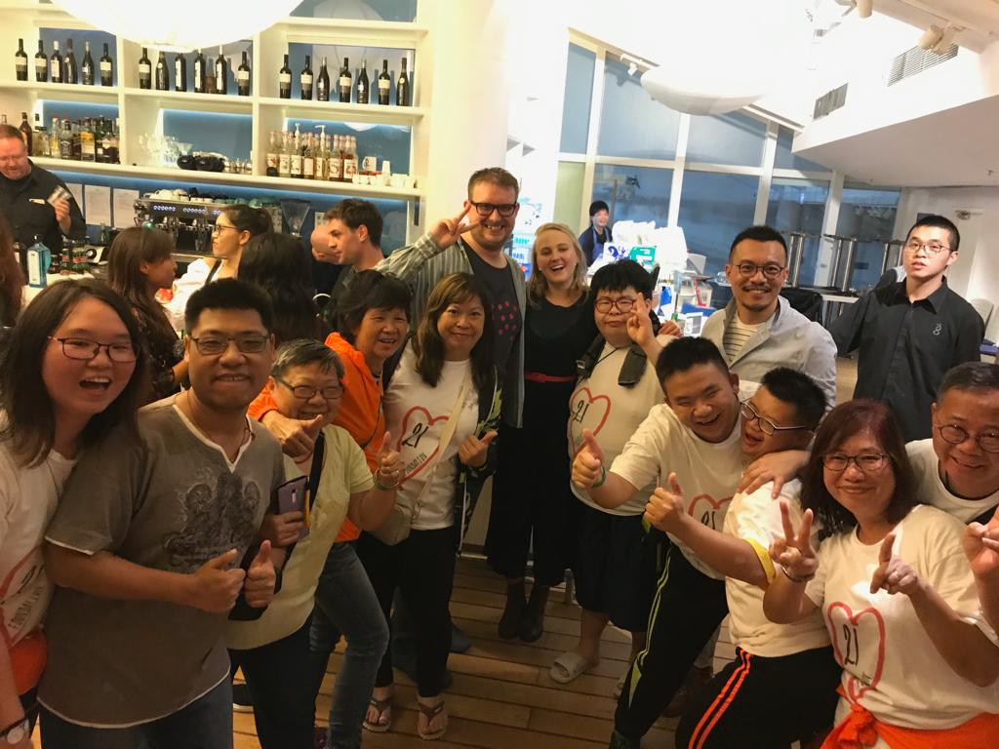

Our Beneficiaries
Age
The majority of our beneficiaries are aged between 19-30 in 2018-2019, totaling 73% of our 37 registered participants. The total number of registered families increased from 28 last year.

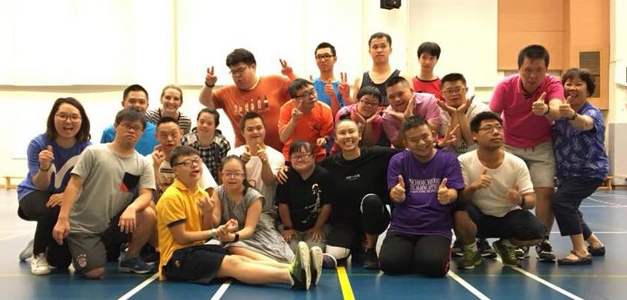
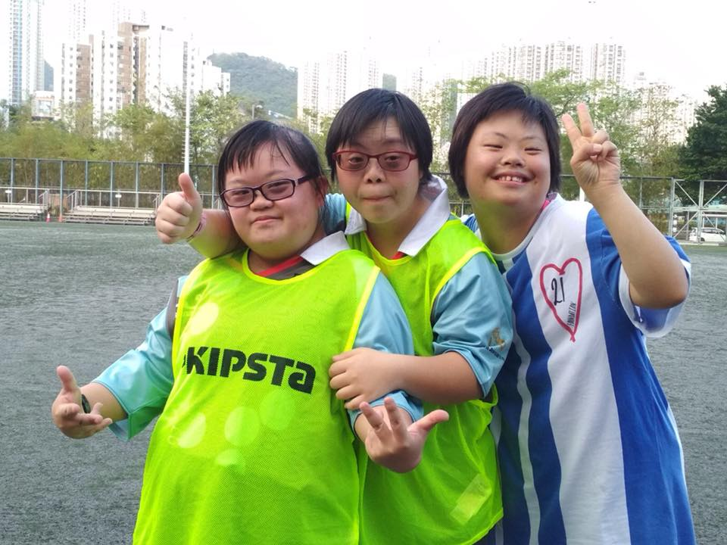
Diagnosis
65% of our beneficiaries have Down syndrome, while the remaining 35% are autistic, epileptic, or have other intellectual disabilities.

Program Summary – Sports
Sport classes continue to be the core of our operations at Love 21 Foundation. Through our classes, we emphasize the importance of physical activity to our participants and their caregivers, something often neglected while they are caring for people with Down syndrome or autism.
In 2018 to 2019, Love 21 Foundation offered on average 10 hours of sporting classes per week, totaling to over 520 hours for the year. This year, we’ve expanded into offering 12 types of sports for our members to choose from. As always, our participants are free to attend the lessons that best suit their interests. We also encourage parents to join our classes to further promote inclusivity in our programmes. Our class offerings for 2018-2019 included:

- Trampoline
- Tennis
- Football
- Yoga
- Zumba
- Basketball
- Gymnastics
- Hip Hop/Jazz
- Hiking
- Fitness
- Salsa
- Rugby

Trampoline
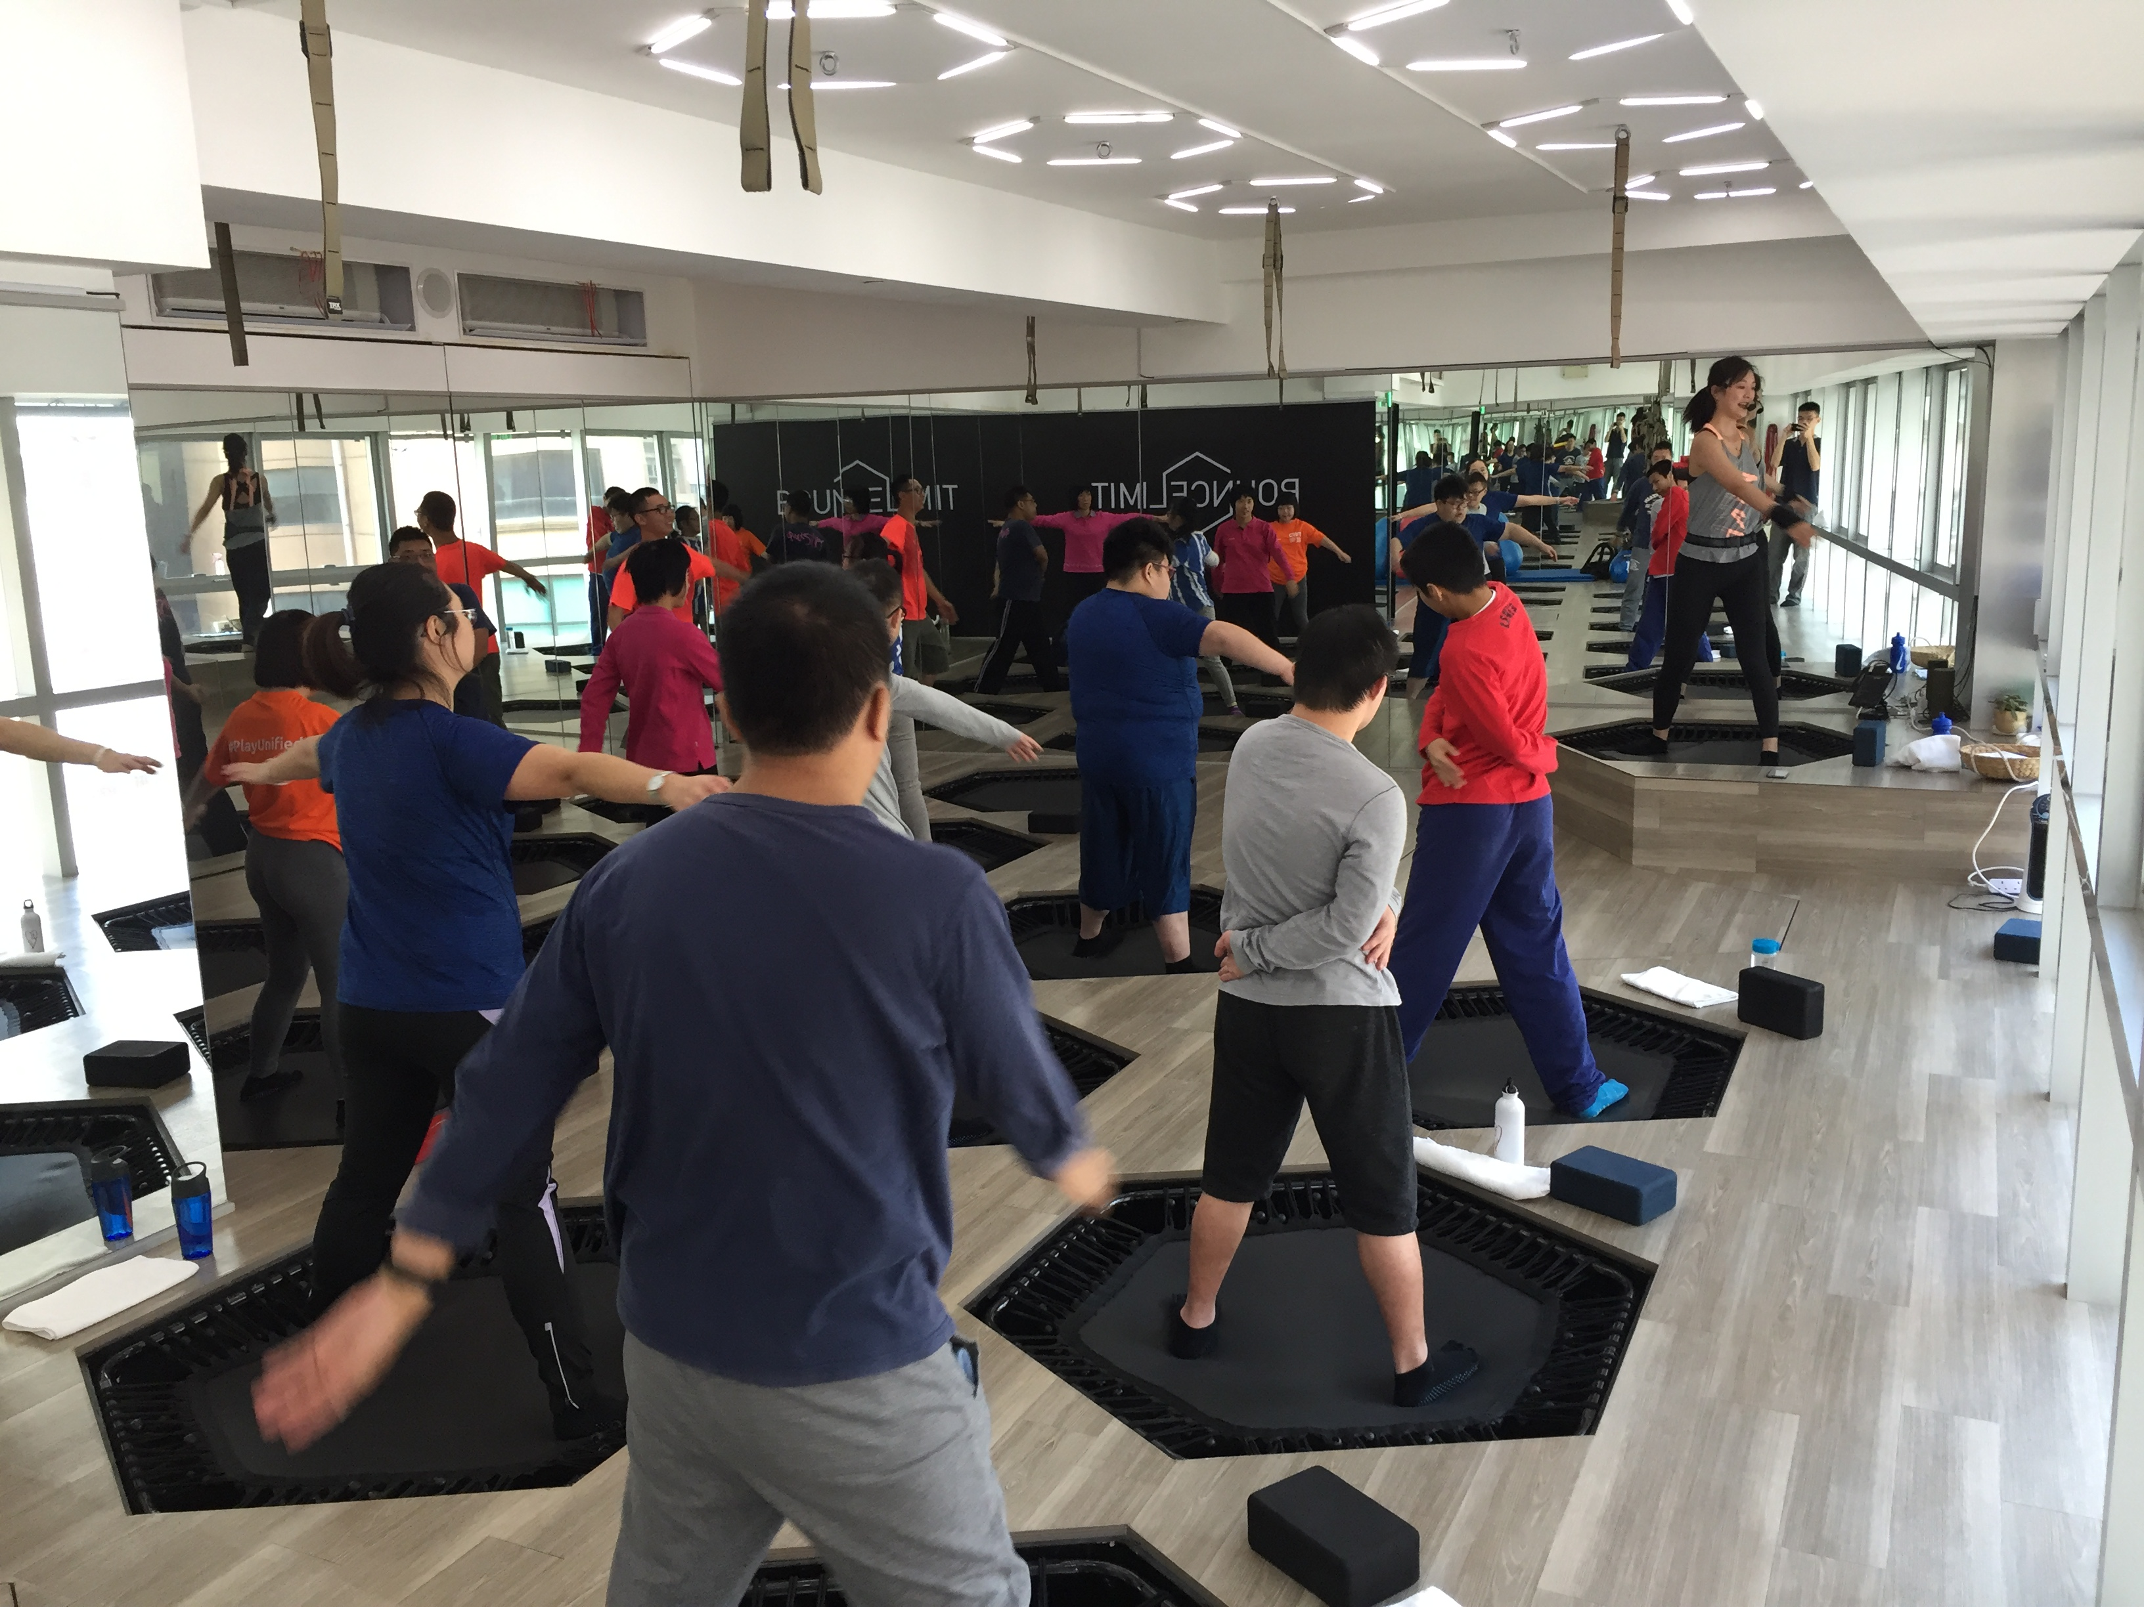
Our weekly trampoline classes continued at Bouncelimit in Sheung Wan every Sunday morning. The trampoline classes remain as one of our most popular classes with an average weekly attendance of 14. Natasha and Belinda (our coaches) engaged our participants in medium intensity fitness routines in our hourly sessions on rebounder trampolines. Routines mainly focus on improving core and lower body strength, as well as enhancing coordination and balance. The current trampoline class that takes place on Sunday mornings is full, and we have new members who have expressed interest in joining the trampoline classes. Looking forward, our goal is to set up and open another trampoline class for interested participants.

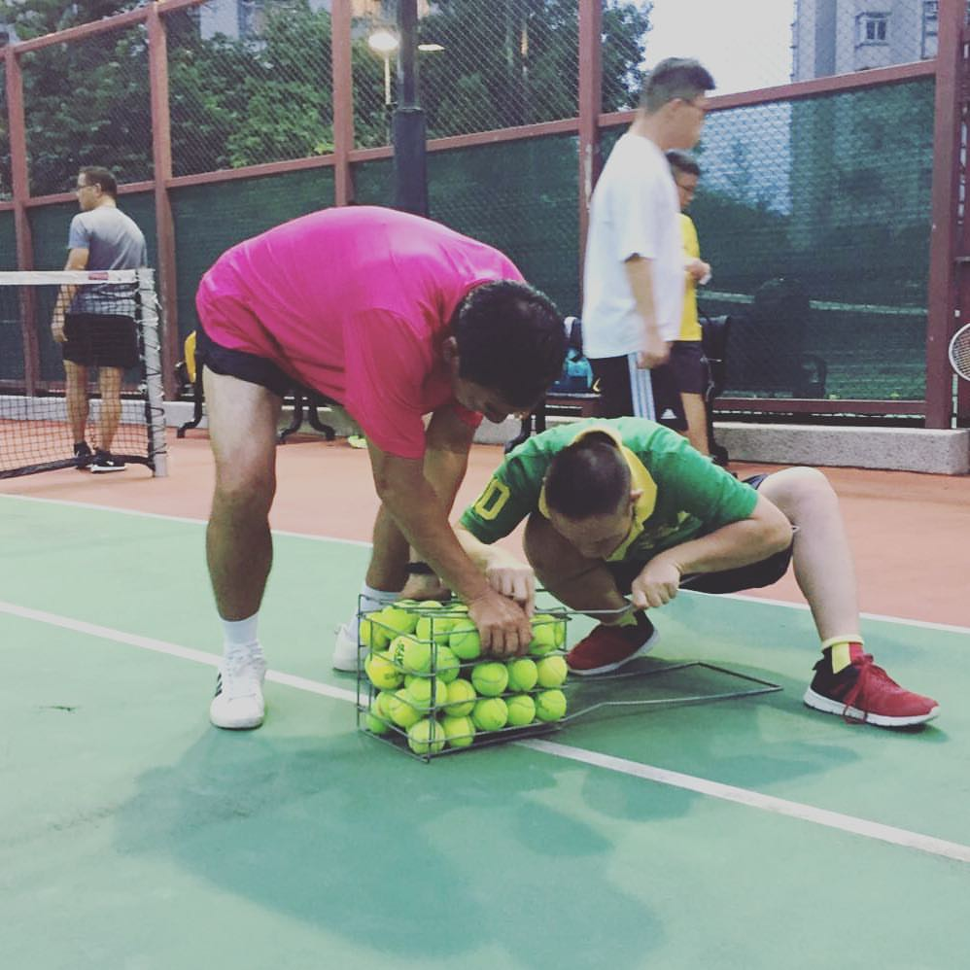
Tennis
Our two-hour tennis classes on Sunday evenings took place at various locations around Hong Kong, including Quarry Bay, Ho Man Tin and later Sai Wan Ho during the first half of 2018. Participants worked on receiving forehand, backhand and improved their techniques on receiving forehand, backhand and volleys. Emphasis was also placed on footwork, coordination and spatial awareness. Unfortunately, due to other commitments, our coach was not able to continue to commit to teaching the weekly class. We are looking for suitable volunteers to help!
Football
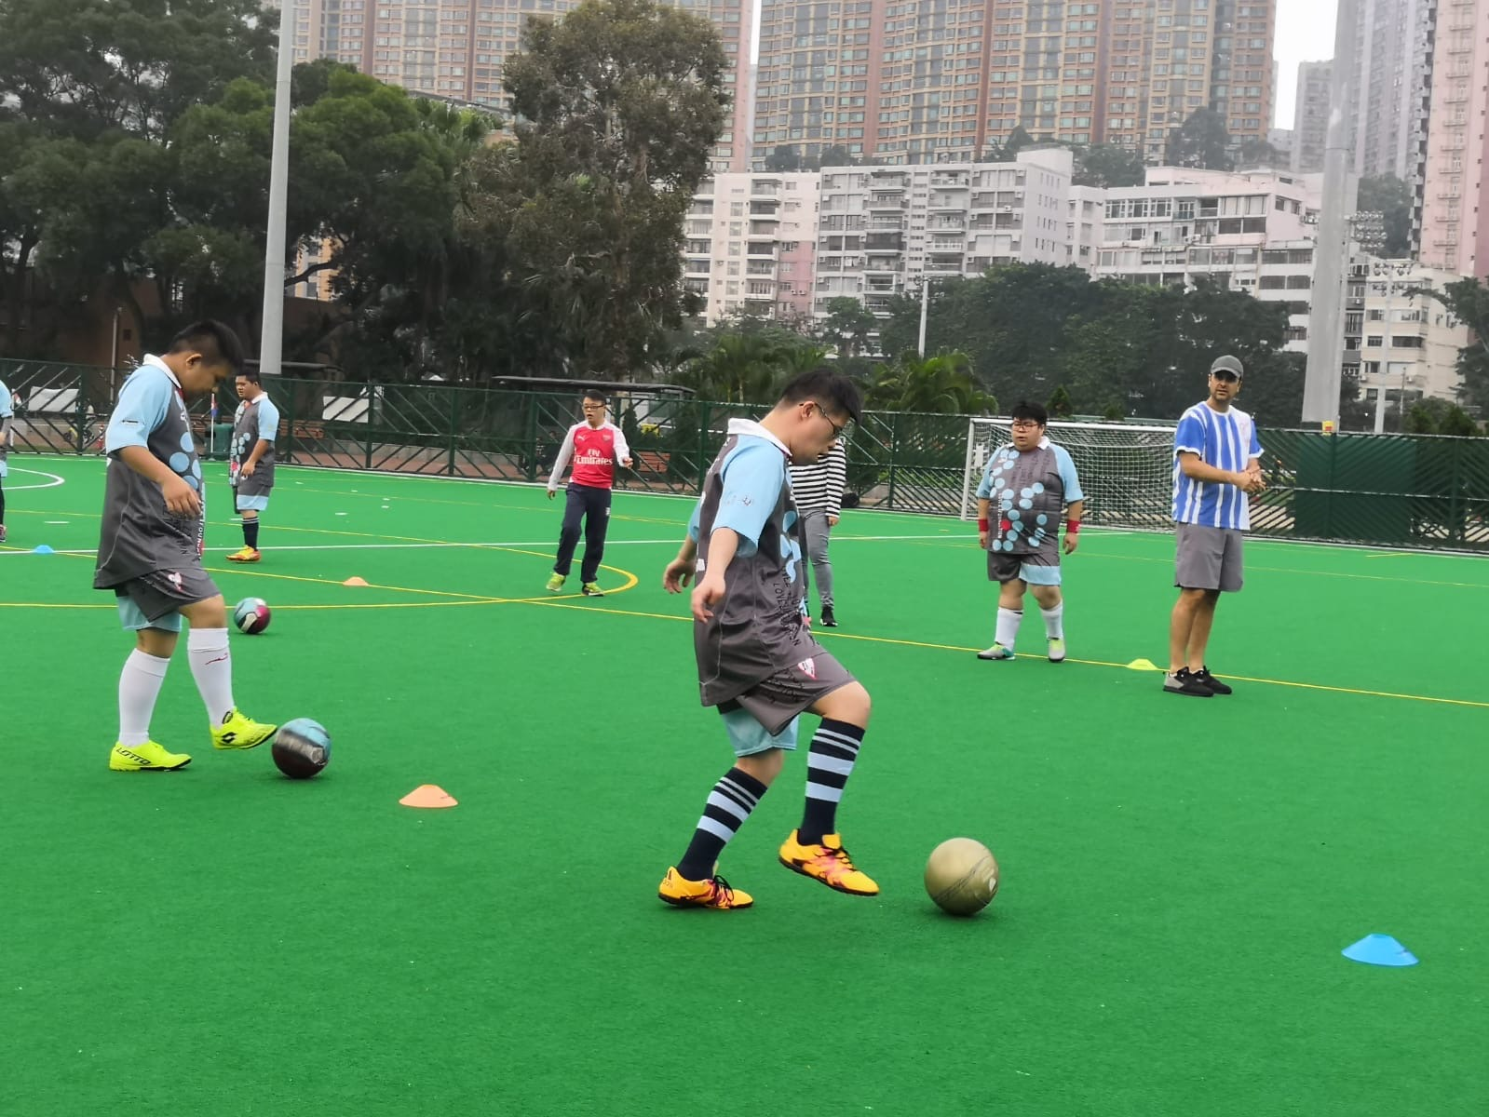
Our football sessions, coached by Jeff and Matt, were one of our most popular classes by attendance. The classes took place at various LCSD football pitches, later at the football pitch at YCIS. In addition to working on their passing, dribbling and shooting skills, we’ve also emphasized the importance of teamwork through teambuilding exercises and drills. Our classes usually end in a match, where everyone runs around having a good laugh. In the upcoming year, we hope to have access to a consistent venue, which would be convenient for both our families and the coaches.
Yoga
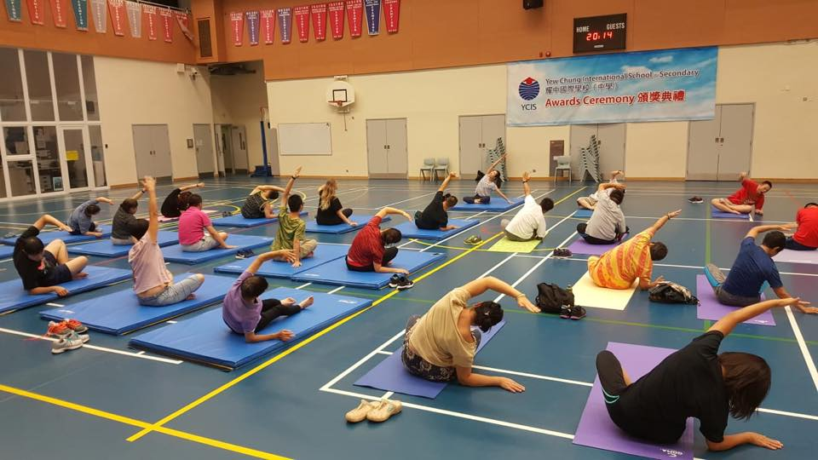
Our weekly yoga classes took place at YCIS, and proved to be a popular class for our parents as well as members. Classes revolved around improving the flexibility and balance of our participants without risking over exertion. We hope that we can continue to offer yoga classes for our participants in the upcoming year, as it’s a class that is suitable for all of our members with different physical abilities.

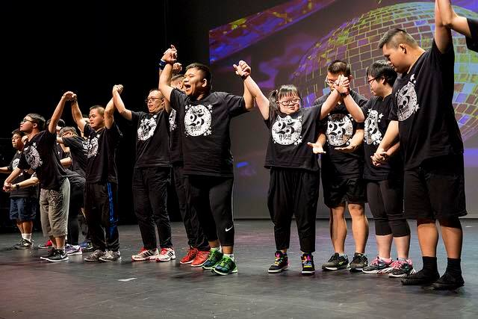
Hip Hop/Jazz
Our hourly Hip Hop/Jazz dance class took place at YCIS every Wednesday. Classes start with warm up moves and stretches, after which participants learn an ongoing dance sequence choreographed by our dance instructor Kim. We are greatly thankful for the opportunity for our dance team to perform at the annual Island Dance show on the 24th of June 2018. Our members are looking forward to showcasing their work and progress in the next annual dance show.

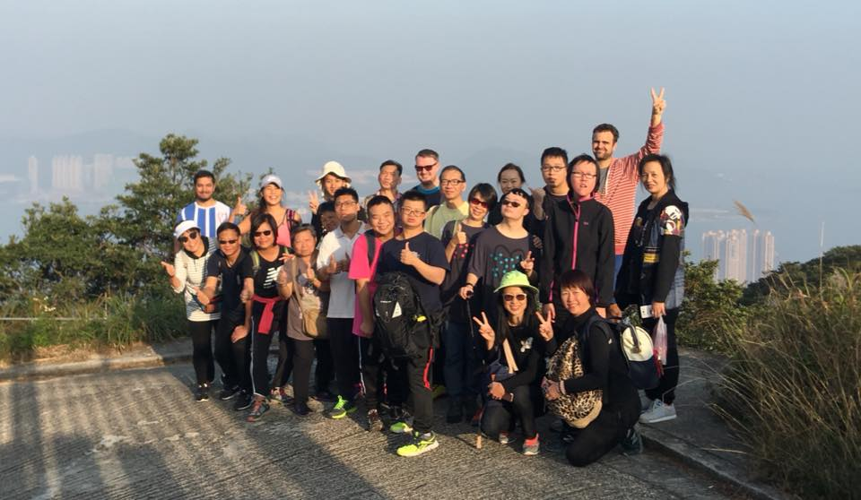
Hiking
Whenever weather permitted, our volunteers and Jeff would lead our members to explore the numerous mountain trails in Hong Kong. Some of the most memorable hikes included Mount Parker and Pok Fu Lam Reservoir.

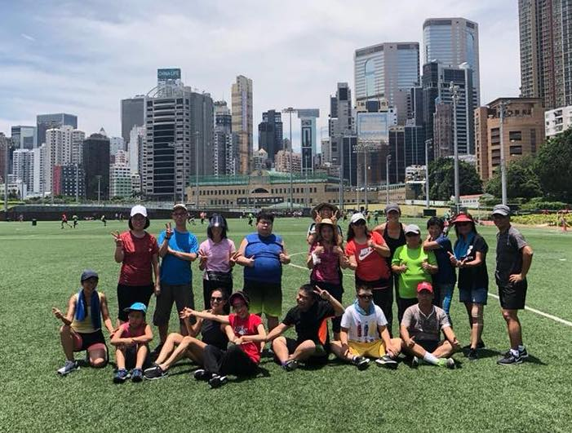
Fitness
Our weekly classes in Happy Valley with Stephanie are a fun and engaging way for our members and their family members to be active in the sun. In addition to playing fitness games, we’ve also worked on improving core, cardiovascular and muscle strength through individual and team exercises. Stephanie has also offered to teach personalized fitness classes at her studio in Central for some of our members who wish to further improve their fitness.

Basketball
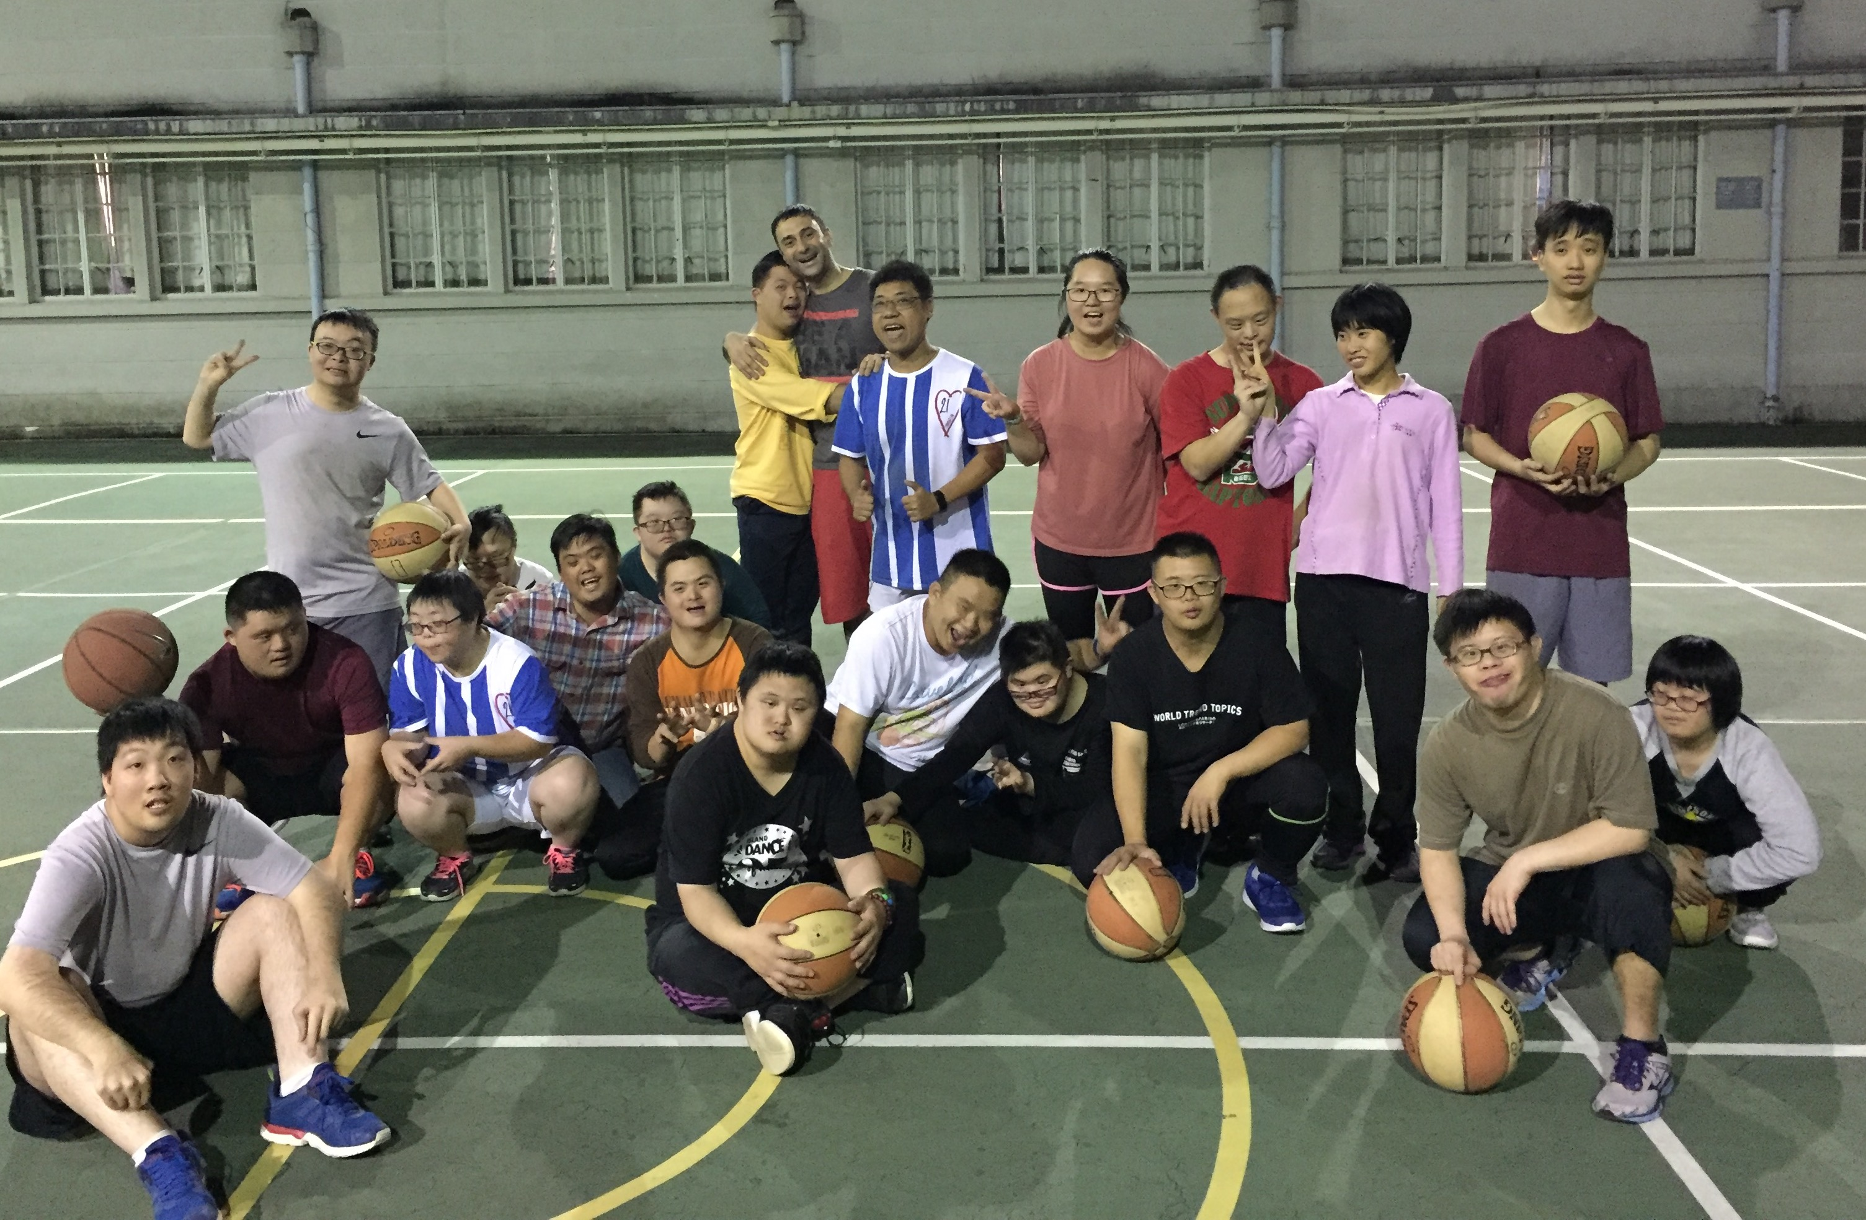
Eric, our basketball coach, led our weekly basketball classes at YCIS starting in July 2018. Our classes started from the basics, with emphasis on passing and dribbling. For some of our more advanced players, we’ve progressed to shooting and rebounds. Since our basketball team is relatively new, we’d hope to further develop our basketball classes in the upcoming year.

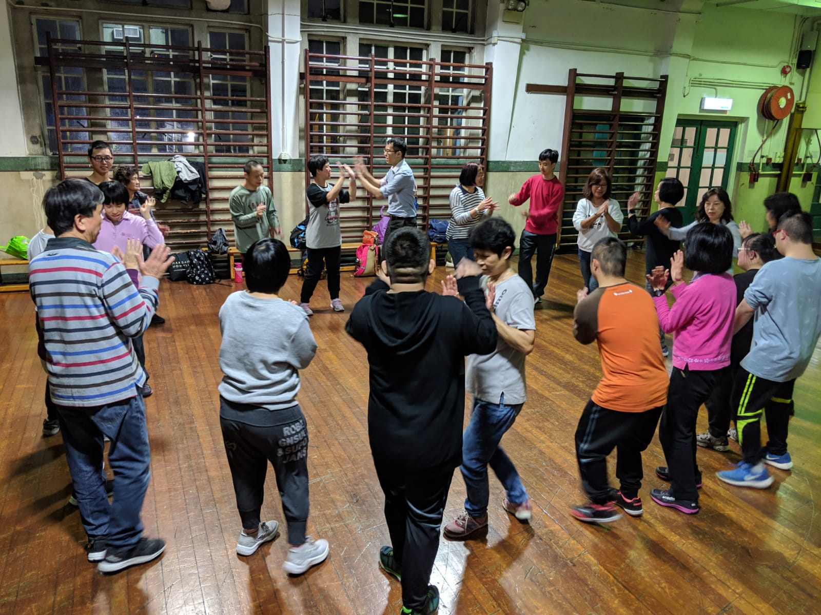
Salsa
Our passionate salsa teacher Andrew introduced salsa dancing to our community in September 2018. Our salsa classes prove to be quite popular for our parents and our volunteers. Our participants enjoy learning the basics of a social dance, and we are looking forward to learning more advanced dance moves in the future for our members who are up for the challenge.

Rugby
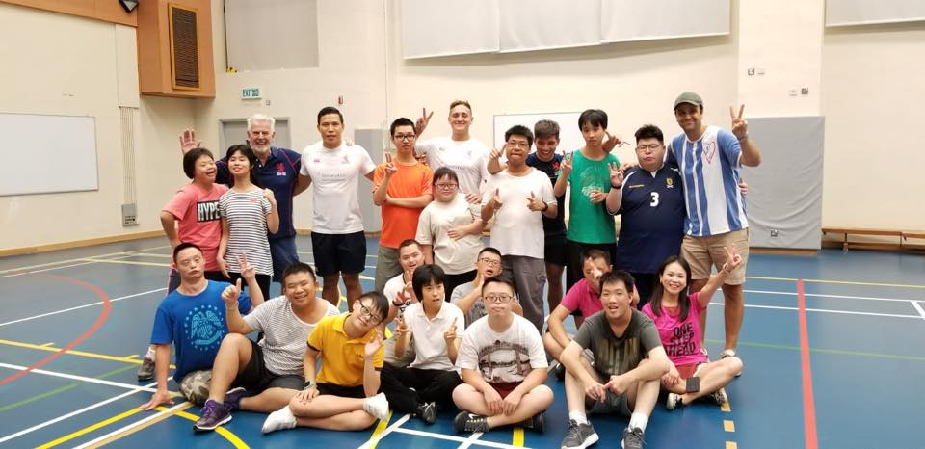
Our newest sport rugby has been a huge hit! And, no we aren’t playing full contact!!
Our rugby classes involve passing, running and kicking! Rugby is another great team sport for our community and we’re very excited to continue developing this programme!

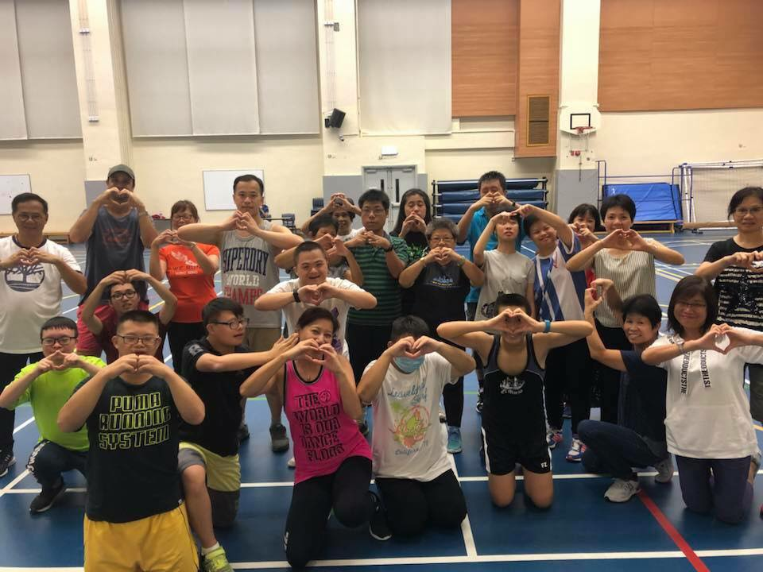
Zumba
Zumba is all about music, movement and fun! And this combination is perfect for our amazing community! This is one of our full family classes where the parents can also join in and sweat with us. Zumba is one of those classes that’s so fun you forget it’s exercise.

Program Summary – Nutrition

Cooking class (November)
Our Love 21 cooking class in November saw a turnout of over 20 families. Needless to say, our first ever cooking workshop was met with enthusiasm from all participants. Not only was the workshop fun for our participants, it was also a great chance for our parents to learn about the importance of cooking and eating healthily. Our families made healthy soups, snacks and shakes with the help from the instructors, and everyone enjoyed a nutritious meal after the class. This will hopefully be the first of many cooking workshops for the Love 21 community.

Partnership with Magic Seasons
As part of our effort to promote healthy eating, we’ve devised a pilot programme for our members to get free organic vegetables based on their level of participation in our sport classes. Since November 2018, we’ve been partners with Magic Season Organics, who have agreed to provide our members with organic vegetables at a steep discount. In certain classes of the week, our members would receive a box of organic vegetables for attending the class. From November 2018 to March 2019, we’ve handed out around 120 boxes of vegetables to over 30 families. We look forward to continuing our partnership with Magic Season Organics in the upcoming year.
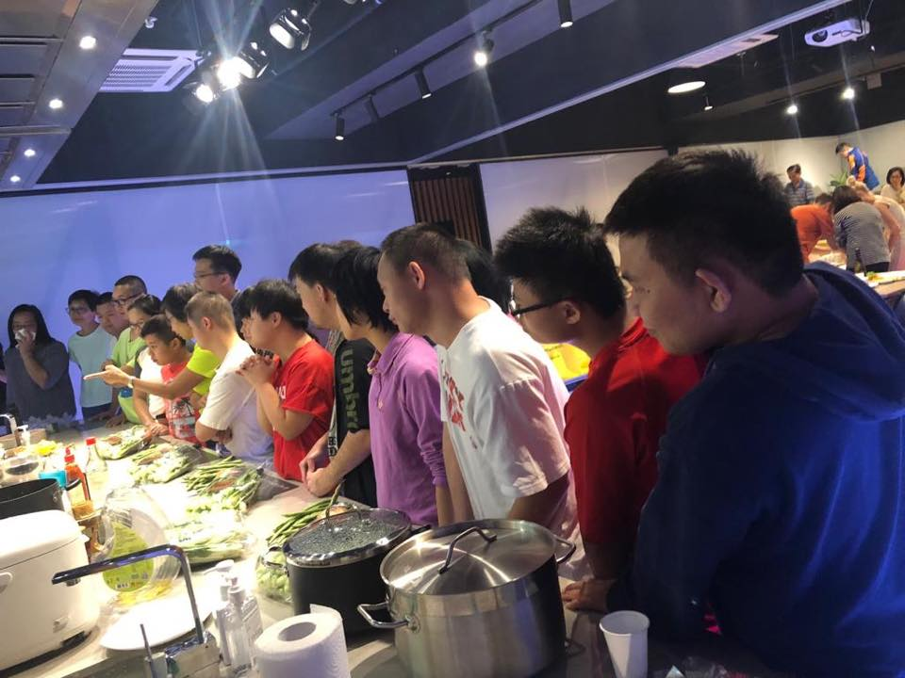
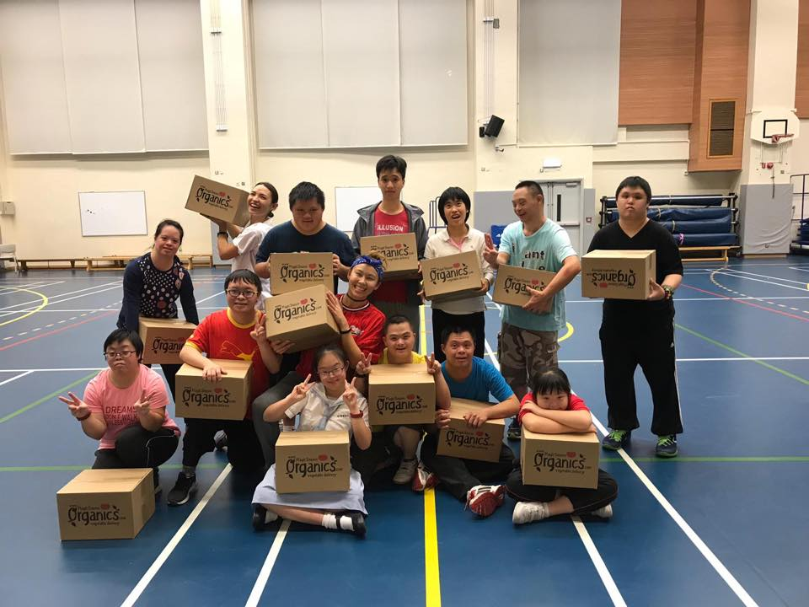
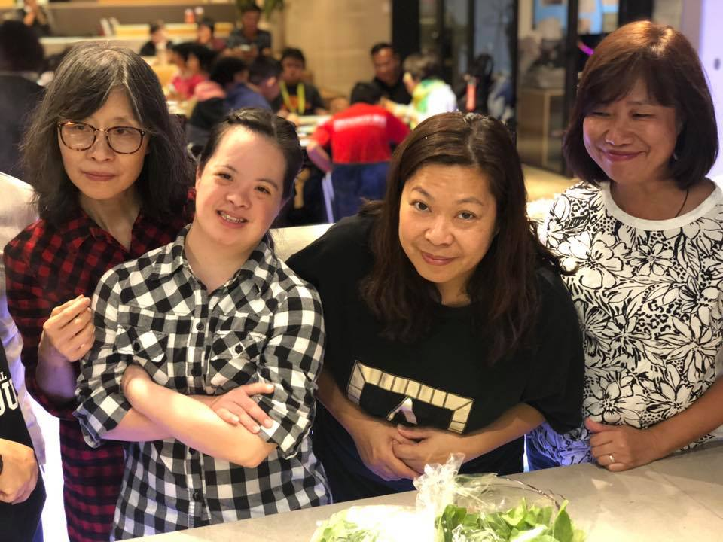

Special Events and Functions

Our Love 21 family love getting together and having fun! This past year we had a number of unforgettable social events.
The highlight of the year was our trip to Macau. On this trip we stayed two nights near the beach in Coloane. We enjoyed swimming, hiking and the beach. At night we played games, ate delicious meals and of course danced!
As a special treat for our parents, we hired a bus to pick up the parents on one evening. They were told to dress up but didn’t know where they were going beforehand.
To their delight they were taken to a fancy hotel for a delicious buffet dinner, while their children stayed with our staff and volunteers for dinner and games.
It was so nice to be able to provide a fun night for the parents and judging by the smiles on their faces when they returned, it was so appreciated!
Throughout the year we also participated in a number of fun social events, from charity hikes and runs, to cooking workshops.
We want to continue providing as many opportunities for our families to connect and have fun as possible!
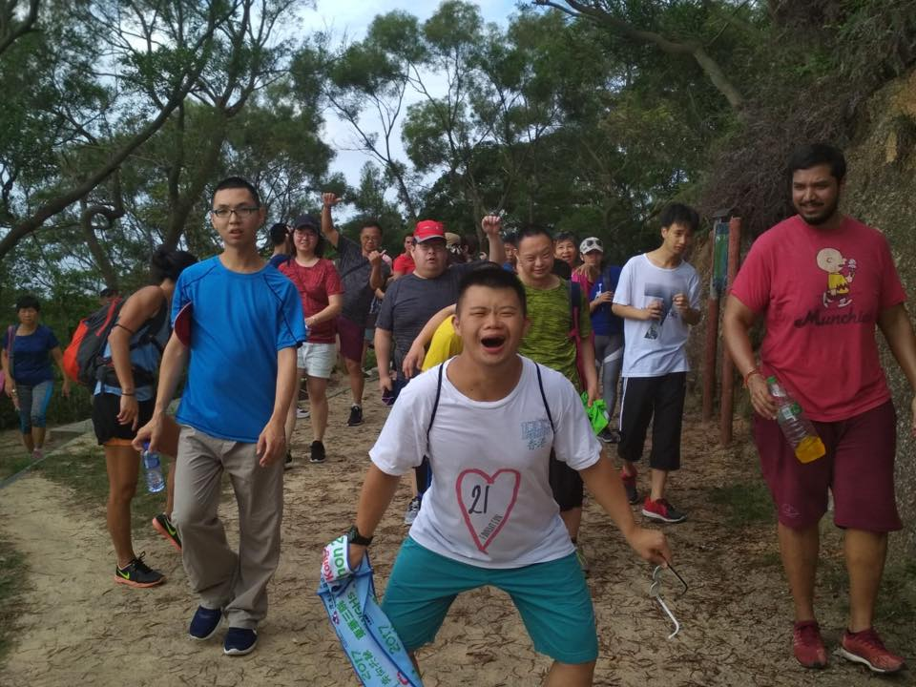
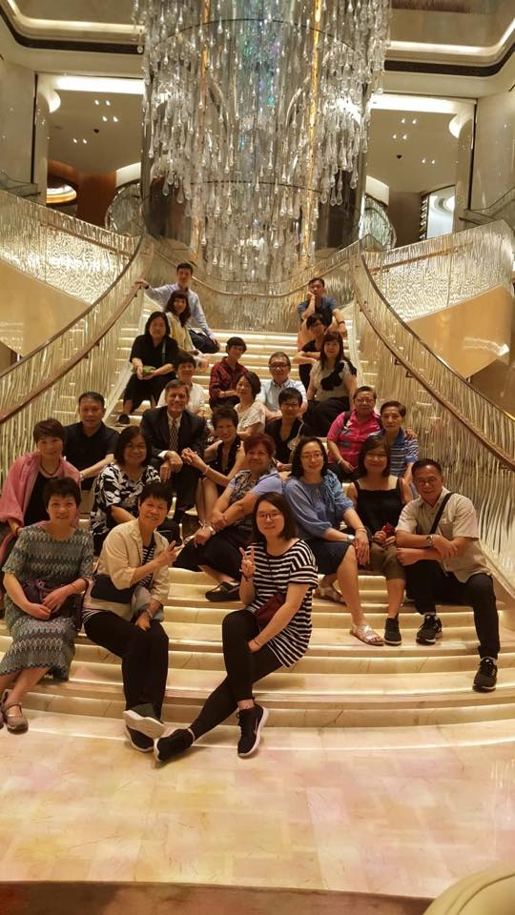
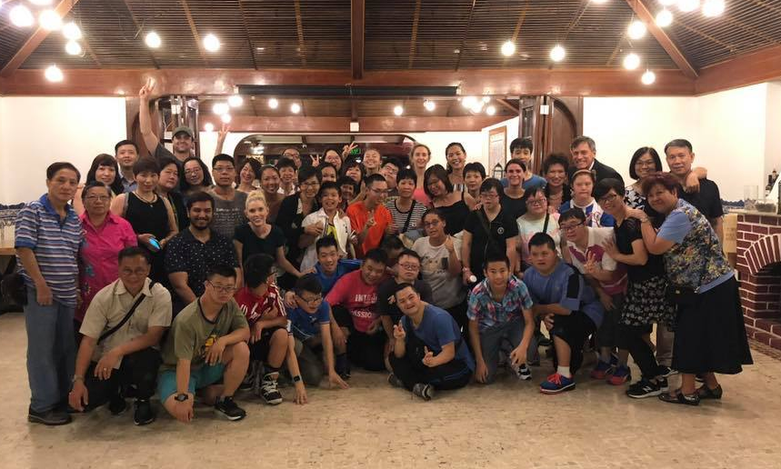
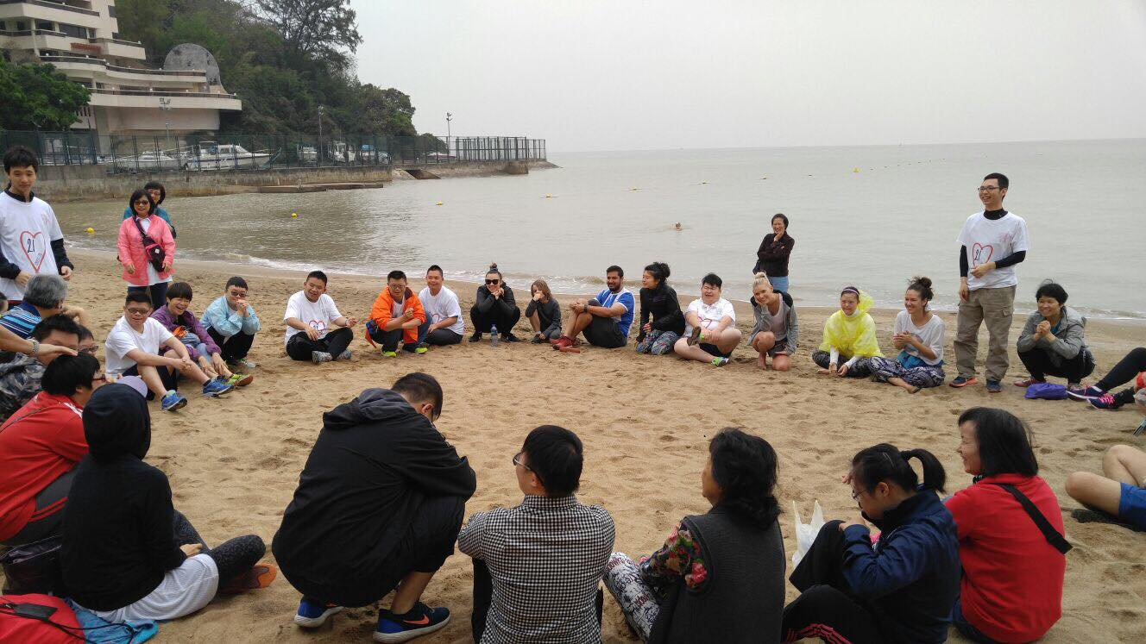

Our Financials
Funding Model
Love 21 Foundation receives no government funding or support. We rely upon donations, sponsorships and fundraising events to generate income as all of our classes and activities are offered to our beneficiaries free of charge. Love 21 Foundation is deeply thankful for all the donors who made generous donations to make our programmes and operations possible.

Financial Statement Summary 2018-2019
The financial statement summary presented below is based on our audited financial statements* for the period of April 1 2018 to March 31 2019, a full version of which is available upon request.
Years ended March 31, 2019 2018
Income HKD HKD
Donations 700,699 352,130
Interest 253 -
Total Income 700,952 352,130

Expenditure HKD HKD
Programme expenses (190,578) (125,824)
Administrative expenses (36,494) -
Audit fee (7,000) (5000)
Wages and salaries (Programme) (152,250) -
Wages and salaries (Admin) (101,500) -
Total Expenditure (487,823) (153,327)
Surplus for the year 213,129 198,803
As of March 31, 2019, accumulated funds of Love 21 Foundation amounted to HKD 385,012 (2018: HKD 171,883).

* The auditor's report was unqualified, did not include a reference to any matters to which the auditor draw attention by way of emphasis without qualifying it's reports and did not contain a statement under sections 406(2), 407 (2) or (3) of the Companies Ordinance.

Financial Overview 2018-2019
Income
Love 21 Foundation relies mainly upon donations as our source of income. Donations from corporates, charitable foundations and individuals make up for about a half, three-tenths, and two-tenths of our income respectively.
Programme Expenses Breakdown
¹ Salary allocations are made based only on management estimation
Remark: The financial report presented above relating to the year ended 31 March 2019 is not Love 21’s statutory annual consolidated financial statements for that year

We Need Your Help
Coming into 2018-2019, we’ve had great plans and expectations based on the successes that we’ve had in 2017-2018. In the short space of two years, Love 21 has transformed from a charity that offers classes once a week to one that organizes almost daily classes for our beneficiaries. We’ll need your help more than ever in the upcoming year to ensure the sustainable and continual growth of our charity.

Donations
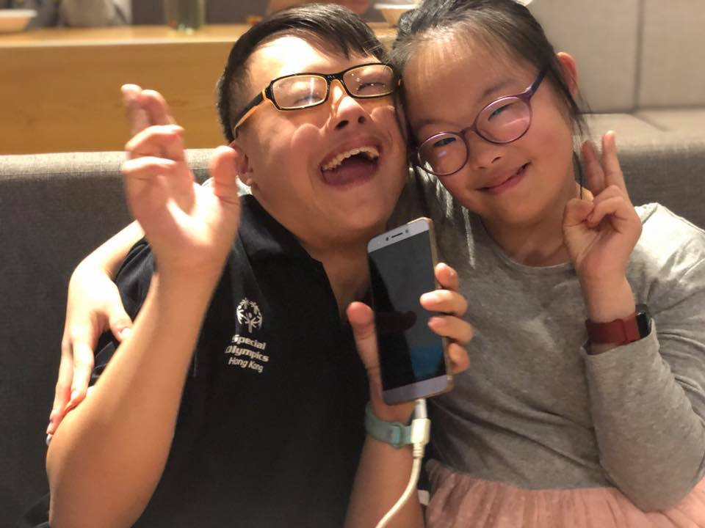
As a charity reliant on donations, we are immensely grateful for any donations that you make. We gladly accept donations, which can be transferred directly to our bank account at 582-350526-838.
Alternatively, donations by cheque can be written to “Love 21 Foundation Limited” and mailed to 9D, Wing Hin Factory Building, 31-33 Ng Fong Street, San Po Kong.
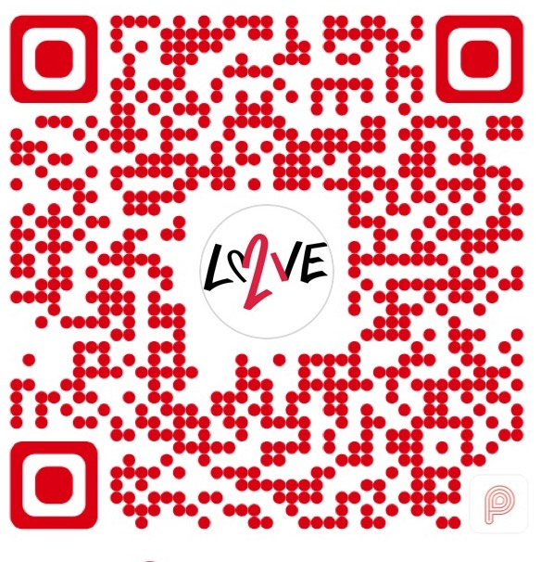
We also accept donations through Payme. Donations can be made by scanning the QR code though the Payme app.
An official receipt for a donation will be issued and mailed to you upon request.

Volunteering at Love 21
We are on the constant lookout for anyone who’d be willing to volunteer with us. Whether it’s leading a new sports class, helping out in an existing class, or assisting us in administrative duties, we welcome anyone who is dedicated, responsible and loving. Simply drop an email to jeff@love21foundation.com or kenneth@love21foundation.com if you’re interested in making a difference.

Thank You to All of Our Donors
2G Sports Association
American Chamber of Commerce
American’s Women Association
Appel Nicholas John & Appel Terri Crystal-Gibbs
Capital International Inc.
Capital International Inc. in honor of Mr. Harold La
Cheung Tin Shing
Dutch Community Gala
Eric Cheng
Erica Malla
Harry De Pree
Jenford (HK) Limited
Joanne Ho
Matthew Hong
Matthew Hosford
Providence Foundation Limited
S N Shroff and Company Limited
Shek Byn Yao
Sofia Chan
Soraya Shroff
Sunraj (HK) Ltd
The Guv Dillon Fund
The ONE HK
The White Stag

2018-2019

Annual Report
nn

Connect With Us!

